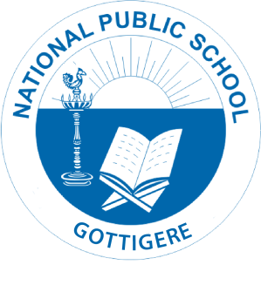
National Public School, Gottigere
Academic Year: 2021-2022
Reopening of School _ Grade IX & X/NPS/ACAD/2021-22/P07

Dear Parent,
Greetings!
The Academic Session for the Year 2021-2022 will resume from 23rd August 2021 as per the Government notification received from Government of Karnataka.
Please note that the Transport Fee is exempted.
Kindly make a note of the below mentioned pointers:
- Offline classes will be conducted from Monday to Friday.
Timing : 8.45 am to 1.40 pm
- Regular Online classes will be conducted as per the schedule on all other working days.
- Students should carry their textbooks, notebooks, etc… according to the Timetable.
- Students should abide by the Covid-19 Safety Protocols. (Maintain social distance, wear face mask and sanitize hands when needed)
- Kindly send sufficient snacks, lunch and water during regular classes.
- Please ensure that if your ward exhibits any symptoms such as fever, cold or cough, requesting you not to send them to school.
- The pickup / drop timing and the route number for your respective ward will be informed through the Teams & Watsapp by your Class teacher.
- Kindly click on the below link to provide your consent for the same by 18th August 2021.

https://forms.office.com/Pages/ResponsePage.aspx?id=F-7l-IAQK0iH4vprD8-d_HBwsnhZUO5JmaMoCHtzr-xUNUQ3UFU2QjhIVE9NTzBVTTZRRkNRWDZQOC4u

Regards,
Principal
National Public School, Gottigere

