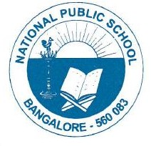
National Public School, Gottigere
CIRCULAR/NPS/ACAD/2022-23/ P – 13
28/07/2022

Dear Parents,

Greetings of the day!

Please make a note of the following instructions shared below for your kind perusal & action.

1. The students will be granted permission for half a day, or in between school hours only in case of emergency or if the parents have taken prior approval over the mail.

2. School will also not hold any responsibility for administering medications to children under medication.

3. The students exhibiting any kind of symptoms like cold, cough or fever are instructed to refrain from attending school till a fitness certificate (medical report) from a medical practitioner is submitted to school.

4. The students are instructed strictly not to carry mobile phones, not to wear expensive jewellery or accessories, smart watches etc.

These instructions are given keeping the safety & security of your child in mind.

Your cooperation in this regard is greatly appreciated.

Regards,
Principal
National Public School, Gottigere

