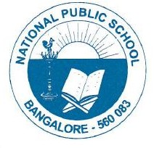

CIRCULARS/NPS/ACAD/2022-23/P 17

Dear Parent,

Greetings!
Kindly fill the form using the link below, to confirm your presence for Independence Day.
https://forms.gle/EYUcePUwV4M2GNem9

Regards,
Principal
National Public School, Gottigere

