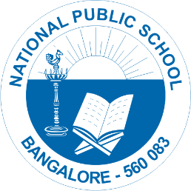

National Public School, Gottigere
School Re-Opening Guidelines AY 2022-23
CIRCULARS/NPS/ACAD/2022-23/P 04

Dear Parents,
Greetings!
Please be informed that after several months of remote teaching, we are excited to welcome our
students back to school. Henceforth, students are required to follow certain guidelines on the re-
opening day of the school.
1. School is going to re-open on 1st June from Grades I-VIII.
2. School timing is from 8.30am -3.00pm.
3. Parents must provide their ward with snack as well as lunch boxes.
4. Students should come in proper school uniforms. Those students who have not received
their uniforms, can come in color dress for few days(only). The students have to wear
their respective house uniform on Wednesday and Friday.
5. Parents must send all textbooks and notebooks along with the stationery items on the re-
opening day of the school. Time table will be given by the class teachers on the first day.
6. Grade VI to X will have school till 12.30 pm on all working Saturdays.
7. ID card is compulsory. Parents should take a print or fill their ward’s details temporarily and
stick it to their school bag on the re-opening day. This should be carried every day until
school provides them their ID card.
8. Parents should ensure that their wards must follow Covid appropriate behavior within the
school premises; mask is compulsory, to carry their own sanitizer and sharing of either food
or stationery items are not allowed.
9. Bus route details, driver details and timings for pickup will be informed soon.
Your support and cooperation in this regard is highly appreciated.

Regards,
Principal
National Public School, Gottigere.

