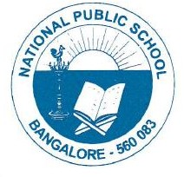
National Public School, Gottigere
CIRCULAR/NPS/ACAD/2022-23/ P – 14
01/08/2022

Dear Parents,

Greetings!

"The most beautiful world is always fancied through imagination."

Please be informed that our school is conducting different kinds of competitions in August to celebrate the essence of Independence Day (Grade I- X). The students willing to participate should give their names to the class teachers by 3rd August 2022.
The participants are required to bring their materials for the respective competitions as mentioned below for your kind perusal.
The students participating in Fancy dress are requested to come dressed from home.

Your cooperation is greatly appreciated in this regard.

Date: 11th August 2022
Timing: 9.00 a.m-11.00 a.m.
Grade: I-V (Fancy Dress Competition).

Date: 13th August 2022
Timing: 10.30 a.m- 11.30 a.m.
Grade: VI- X (Rangoli Making Competition)

Regards,
Principal
National Public School, Gottigere

