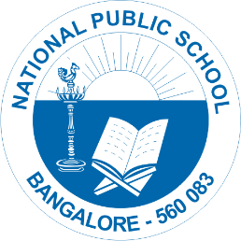

National Public School, Gottigere
Circular for Fee Payment – AY 2022-23
CIRCULARS/NPS/ACAD/2022-23/P 02
Dear Parent,
Greetings!
‘’Education is not preparation for life, Education is Life Itself.”
Education is not just learning about facts; it is more about building our own self-esteem, confidence, and values and expanding our horizons to the different facets of life. Though these years have been extremely challenging for us, however, your cooperation and support have enormously helped us to overcome this milestone.
Going forward, we believe to strengthen our bond and make it a lucrative one.

We wish to inform you that the link to pay tuition fees for the Academic Year 2022 - 2023 is open. Fee can be paid through the ONLINE PAYMENT option available on the school website on or before 30th May 2022.

Procedure for Online fee payment (Through Federal Bank):

1. Visit the school website www.npstj.com --> Click on ONLINE PAYMENT --> Pay Online
2. You may go through the URL https://epay.federalbank.co.in/easypayments/ for the following mode of payments.
*TWO INSTALMENTS PAYMENT
* AVAIL 5% DISCOUNT (BY ONE TIME PAYMENT)

In case you have any queries, please send an email to info@npstj.com with your ward's name, class & section, your mobile number and your query. We shall revert to you at the earliest.
Alternatively

NPS Gottigere has partnered with a company called JODO (www.jodo.in) to provide parents a monthly fee payment plan. With JODO, parents can pay the Academic Tuition fee at 0% interest, as the interest cost is being covered by the school. A plan like this would be beneficial and convenient for a lot of parents especially considering the present situation.

Procedure for Jodo fee payment:

Register at https://app.jodo.in/npstj/login using the Student’s Enrolment Number to access fee details and kindly pay your ward’s fee via two convenient options offered by Jodo.

- Four instalments via Jodo Flex (scheduled auto debit/ECS facility).
- Eight monthly instalments at 0% interest via Jodo Cred (Financing option).
EMI starting from April.
To know more about the Jodo fee payment plan, parents can call 9606108182 or WhatsApp Jodo at https://tinyurl.com/NPSGJODO

Regards,
Principal
National Public School, Gottigere

