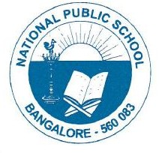

CIRCULARS/NPS/ACAD/2022-23/P 05

AY 2022-2023

Periodic Test I Timetable

Grade- VI to X

Date/ Day | VI | VII | VIII | IX | X
04/07/22  Monday | English | II Lang | English | Science | Social Science
05/07/22  Tuesday | II Lang | Math | Science | Social Science | English
06/07/22  Wednesday | Science | Social Science | III Lang | Math | II Lang
07/07/22  Thursday | Math | III Lang | Social Science | II Lang | Math
08/07/22  Friday | Social Science | English | II Lang | English | Science
09/07/22  Saturday | III Lang | Science | Math

Regards, Principal
NPS, Gottigere

