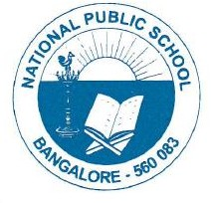

CIRCULARS/NPS/ACAD/2022-23/P 05

AY 2022-2023

Term I MR I –Timetable

Grade- I to V

Date/ Day | I | II | III | IV |  | Date/ Day | V
20/06/22  Monday | Kannada | English | English | Maths |  | 27/06/22  Monday | Science
21/06/22  Tuesday | Hindi | Kannada | SST | Science |  | 28/06/22  Tuesday | Maths
22/06/22  Wednesday | English | Hindi | Science | English |  | 29/06/22  Wednesday | Kannada
23/06/22  Thursday | Maths | EVS | Maths | SST |  | 30/06/22  Thursday | Hindi
24/06/22  Friday | EVS | Maths | Kannada | Hindi |  | 01/07/22  Friday | SST
27/06/22  Monday |  |  | Hindi | Kannada |  | 04/07/22  Monday | English

Regards,
Principal
NPS, Gottigere

