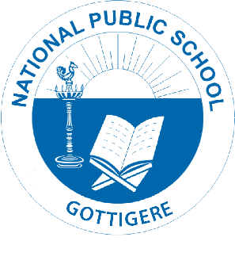
Circular/NPS/ACAD/2021-22/P15
TRANSFER CERTIFICATE

Education is the first step for people to gain the knowledge, critical thinking, empowerment and skills they need to make this world a better place.
Even during this unprecedented pandemic situation our institution and staff have reformed, transformed and given a paradigm shift to the complete concept of imparting education. Not to negate the fact, that it has always been the support of our parents which has enabled us to attain the aura of one of the best schools of Bangalore.
Your succor has always been commendable.

Going further, we would like to inform you that School Leaving Procedure (Transfer Certificate) has started.

So, in case of a withdrawal of your ward you are requested to apply for Transfer Certificate (TC) before 15th March 2022. The parents will be liable to pay the Tuition Fee for the Academic Year 2022-2023, if TC application is received after 15th March 2022.

Please note that No Transfer Certificate (TC) will be issued till all dues to the
School have been paid in full (including returning of Library Books)

Regards,
Principal
National Public School, Gottigere

